Lab 1-01: VirtualBox Installation
1. Copy and paste the following URL https://www.virtualbox.org/wiki/Downloads on the browser to go to the downloads page of Oracle Virtual Box.
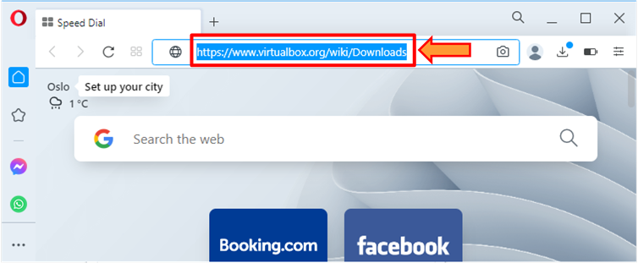
2. Select the Windows hosts to download the Windows executable file.
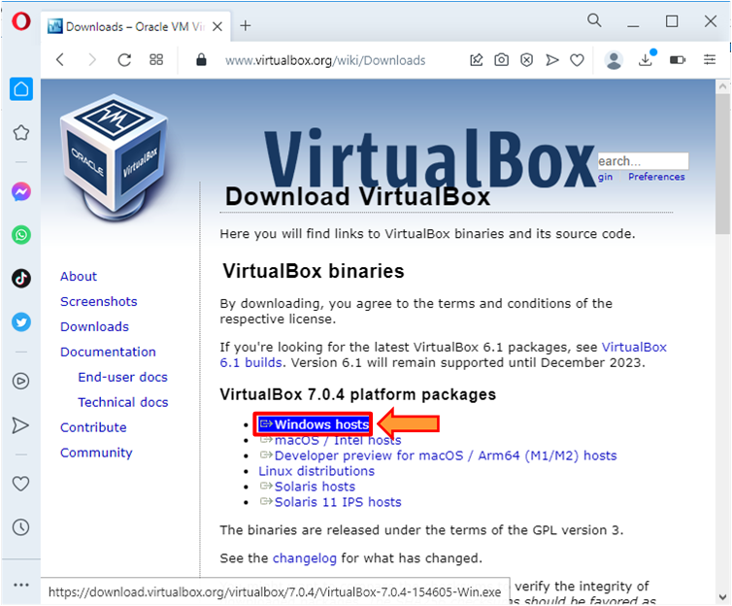
3. Double-click on the downloaded file.
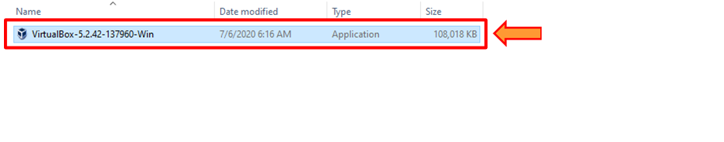
4. Click the Next button.
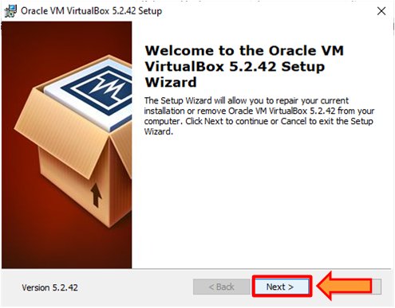
5. Click the Next button.
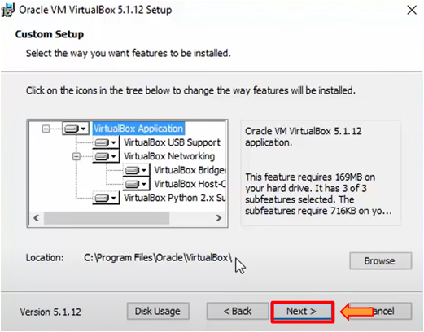
6. Click the Next button.
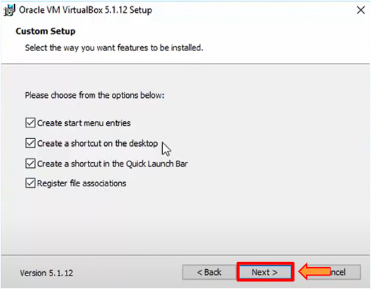
7. Click the Yes button.
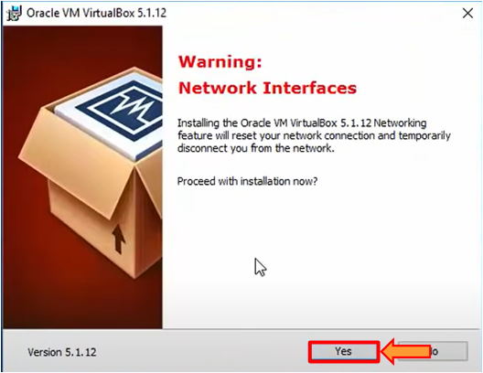
8. The installation starts successfully.
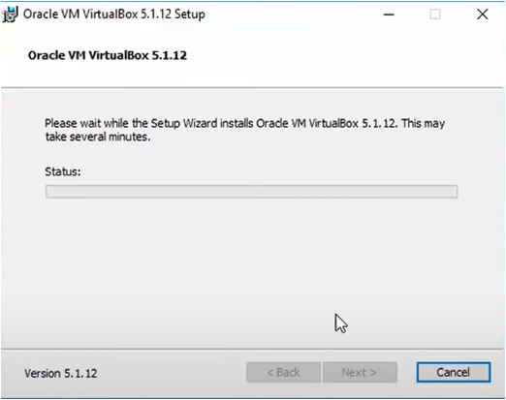
9. Click the Yes button.
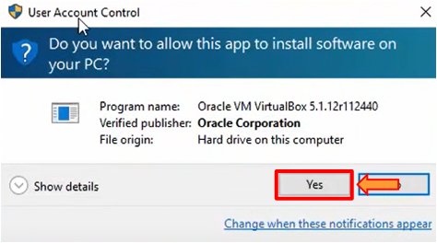
10. Click the Install button.
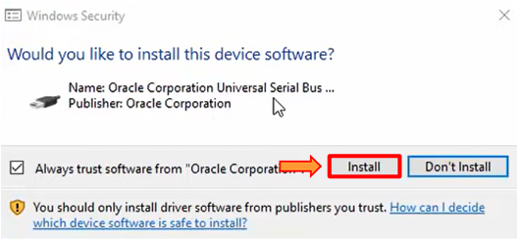
11. Click the Finish button.
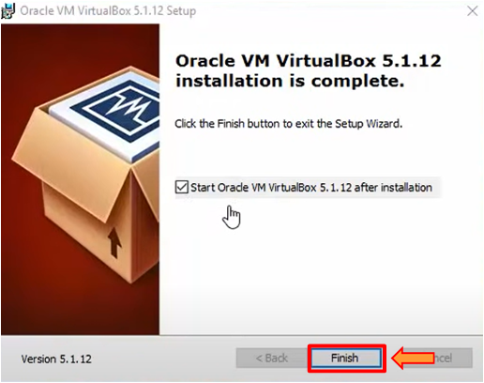

Lab 1-02: Parrot Security VirtualBox Installation
1. Open any web browser and go to the following URL: http://parrotsec.org.
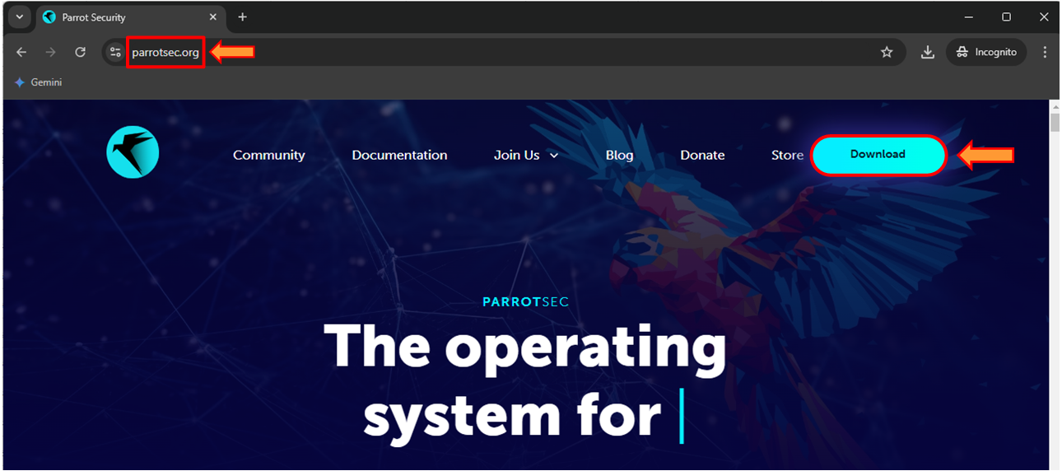
2. Click on the Live.
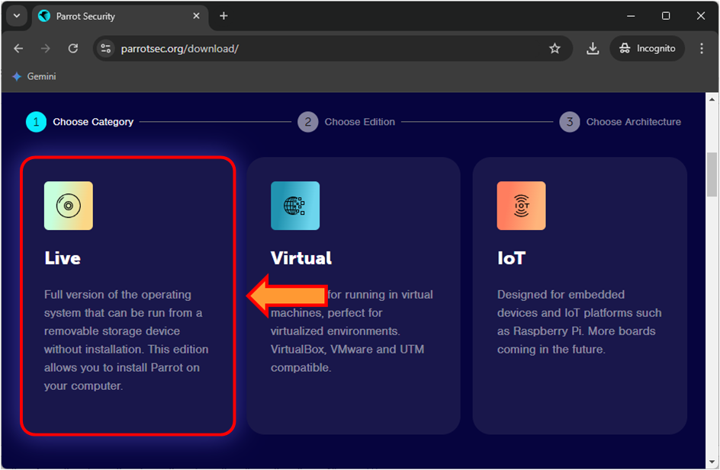
3. Click on the Security.
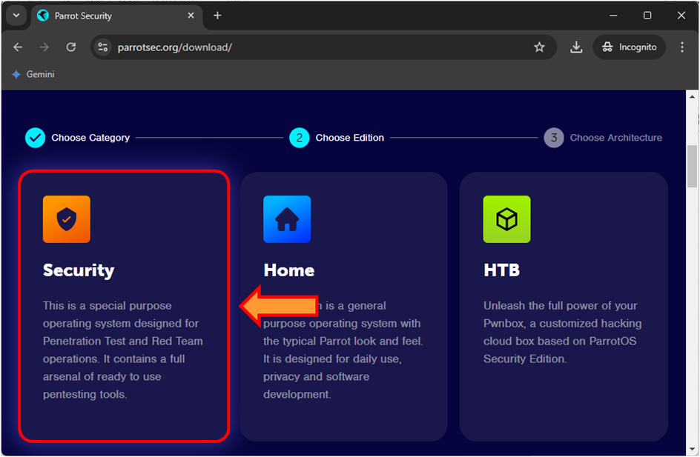
4. Click on the AMD64.
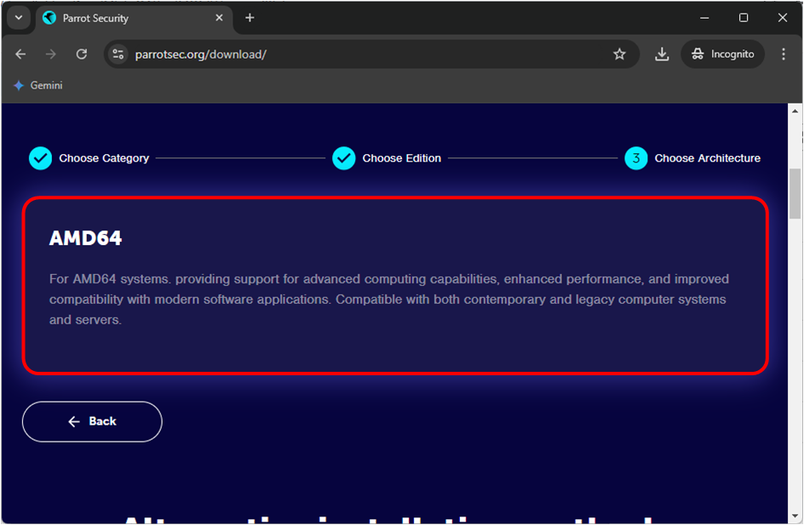
5. Click on the Download button.
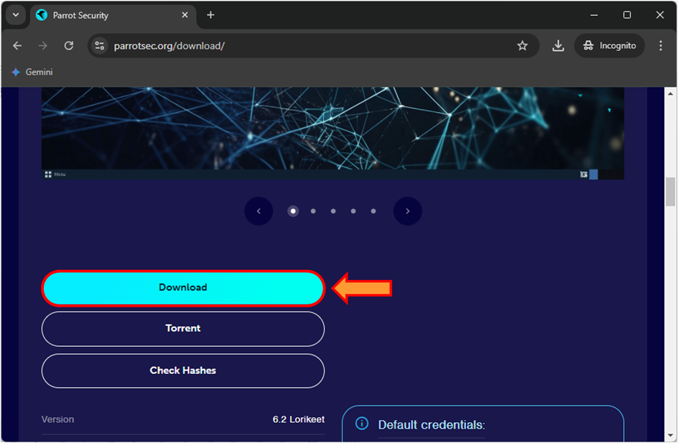
6. Open the Oracle VirtualBox, then click on the New.
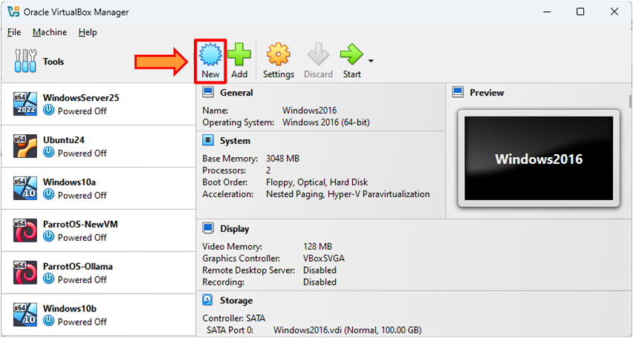
7. In the Name, enter the name of VM ParrotOS-CEhv13. In the Folder, select your desired destination to store it. In the Type, select the Linux. In the Subtype, select the Debian. In the Version, select the Debian (64-bit). After that, click on the Hardware arrow icon.
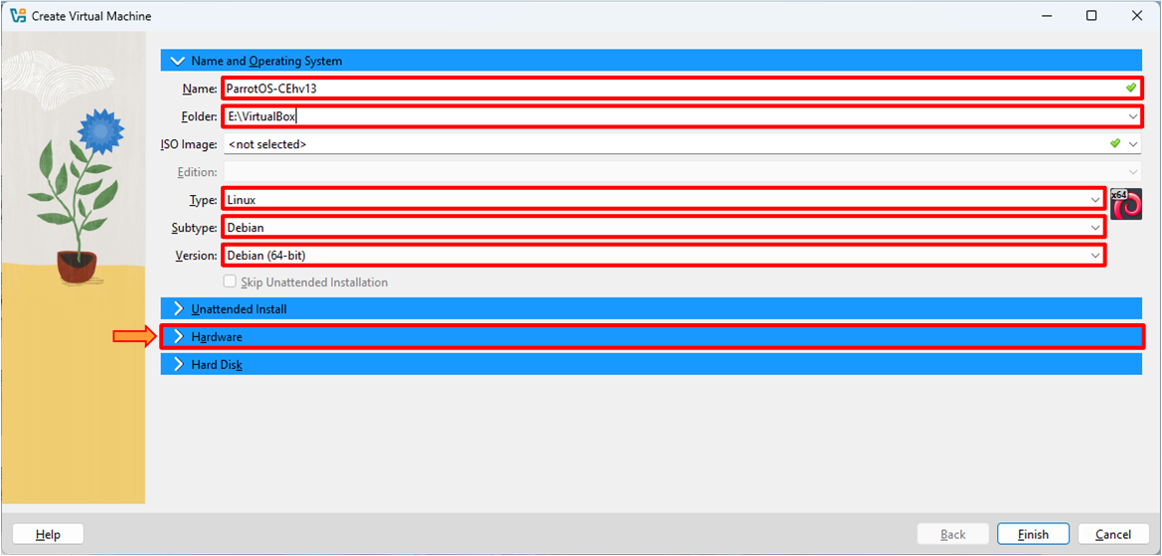
8. In the Base Memory, enter the memory according to your system capacity. For this lab, we are entering 2048 MB, which is around 2 GB. Then click on the Hard Disk arrow icon.
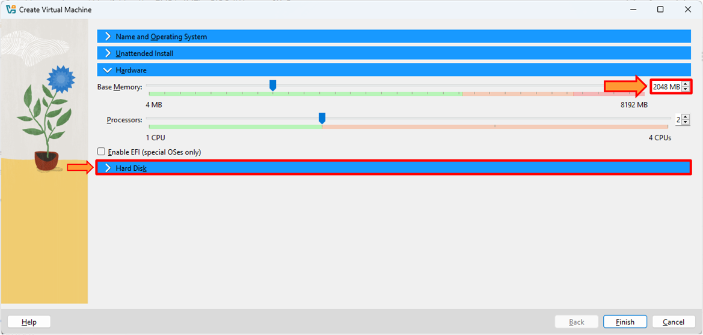
9. In the Hard Disk File Location and Size, enter the hard disk size according to your system capacity. For this lab, we are entering 100 GB. Then click on the Finish button.
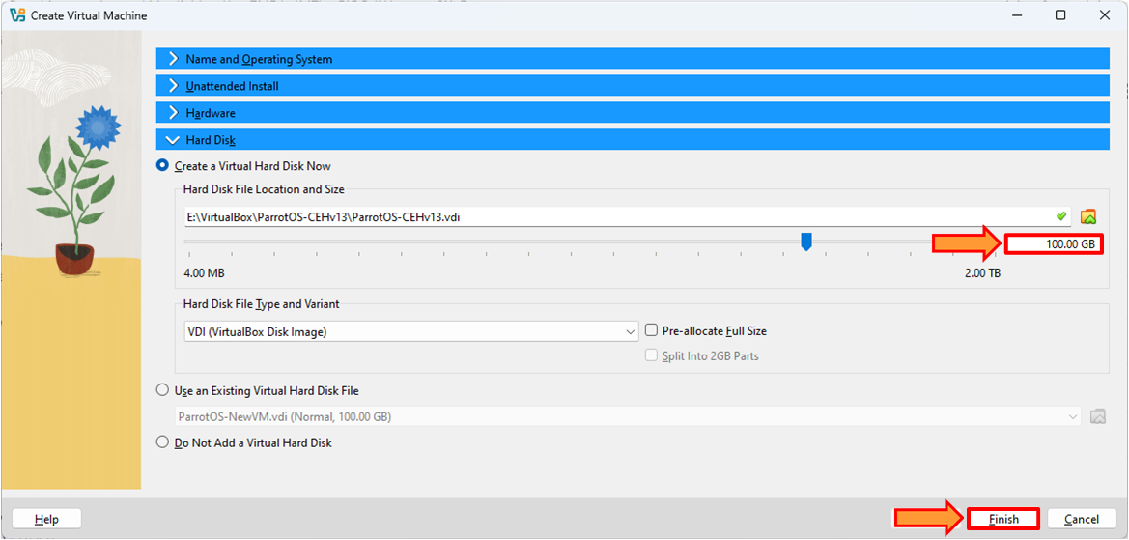
10. The VM is created, but this IOS file is not attached to it. To attach the ISO file, click on Settings.
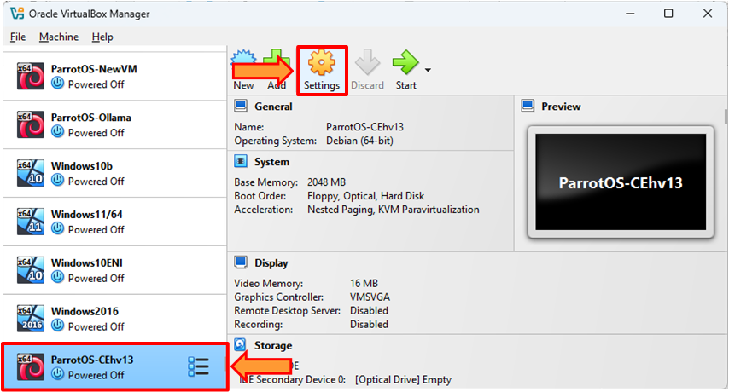
11. Click on the Storage. Click on the Empty. Then click on the Choose a Disk File….
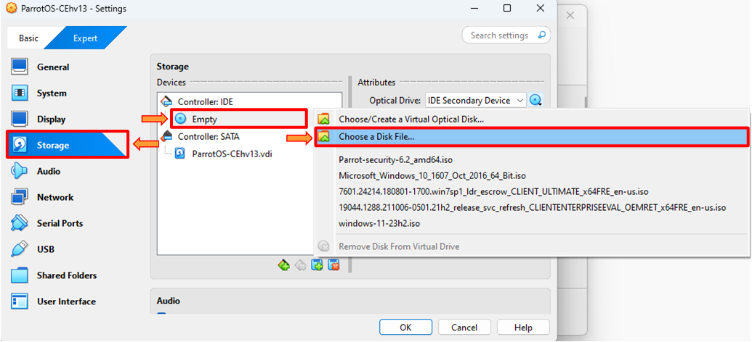
12. The Please choose a virtual optical disk file window appears. Select the Parrot Security ISO file. Click on the Open button.
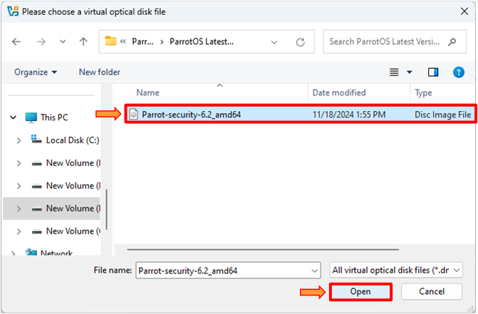
13. Click on the OK button.
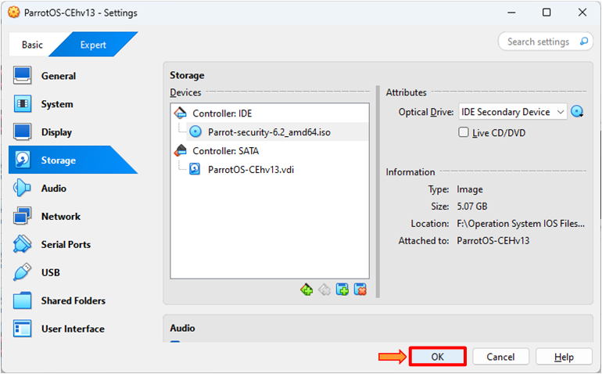
14. Select the ParrotOS-CEhv13 VM and click on Start to proceed with the installation process.
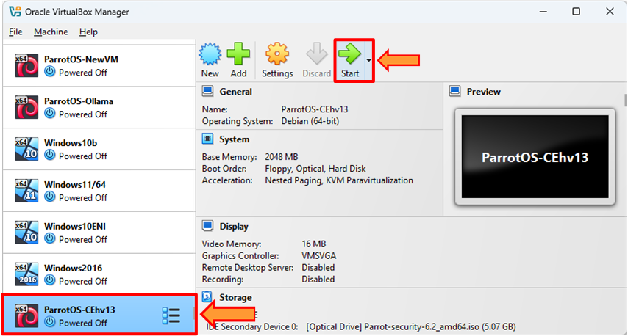
15. Select the Try/Install and press Enter.
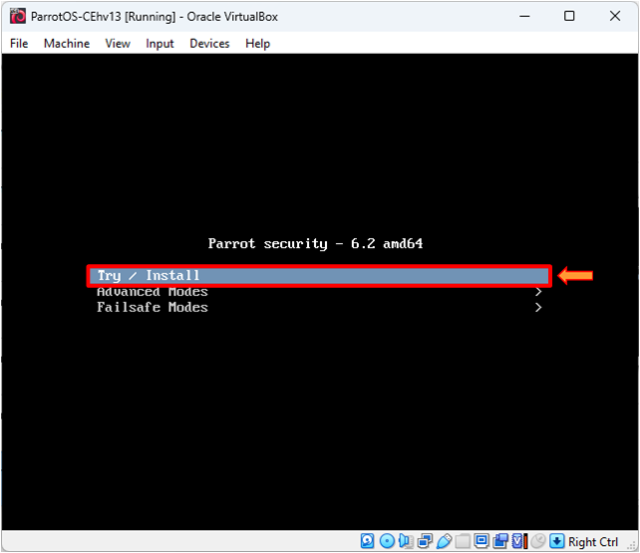
16. Double-click on the Install Debian.
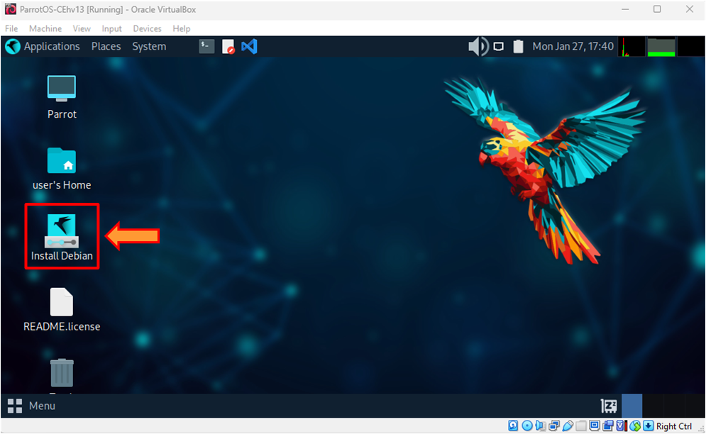
17. The ParrotOS installation window appears. Click on the Next button.
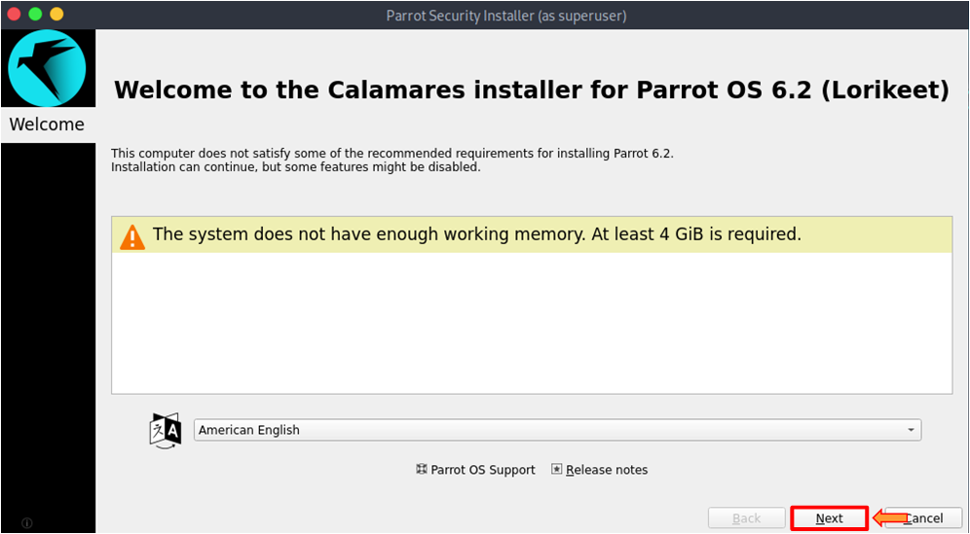
18. Select your Region and Zone, then click on the Next button.
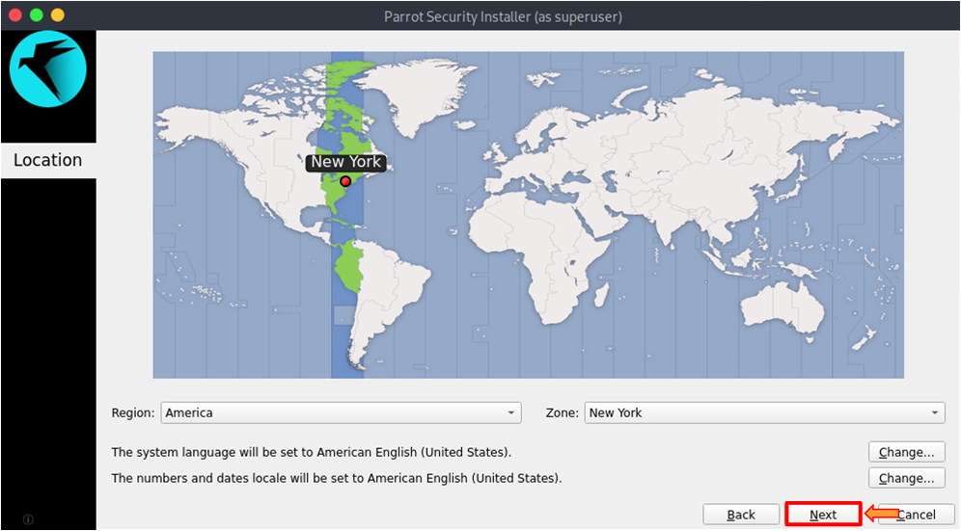
19. Leave the default Keyboard and click on the Next button.
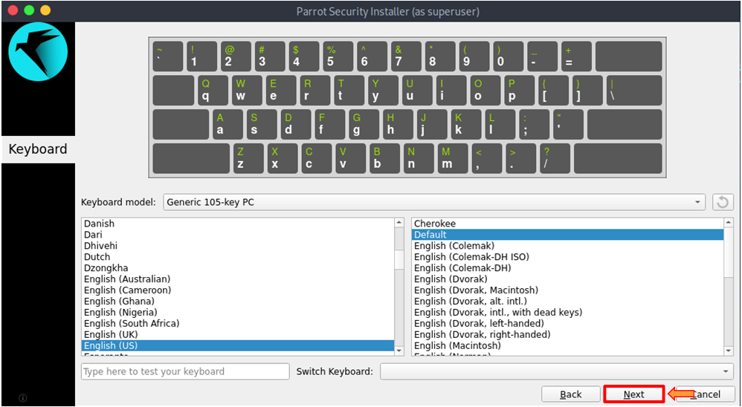
20. Enter your name, computer name, and password. Then click on the Next button.
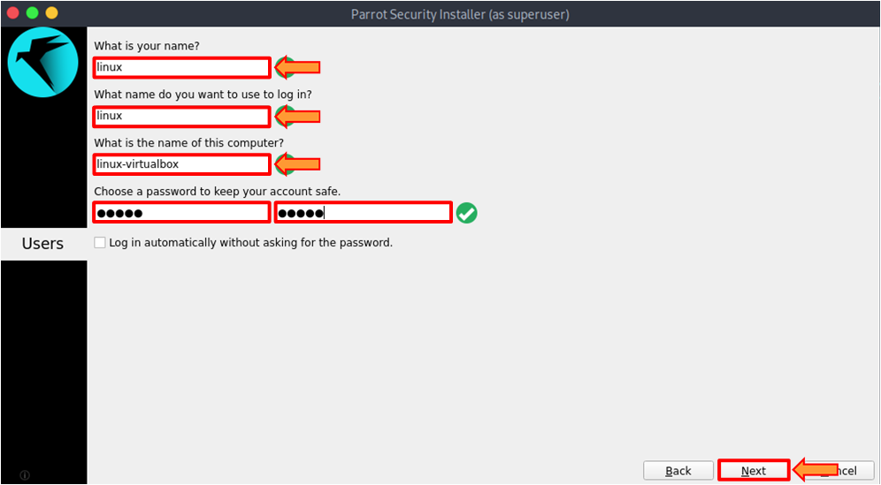
21. Select the Erase disk radio button. Then click on the Next button.
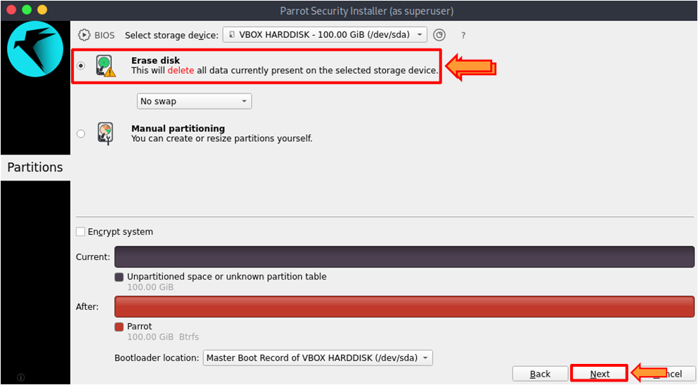
22. A window appears Continue with Installation? (as superuser). Click on the Install Now button.
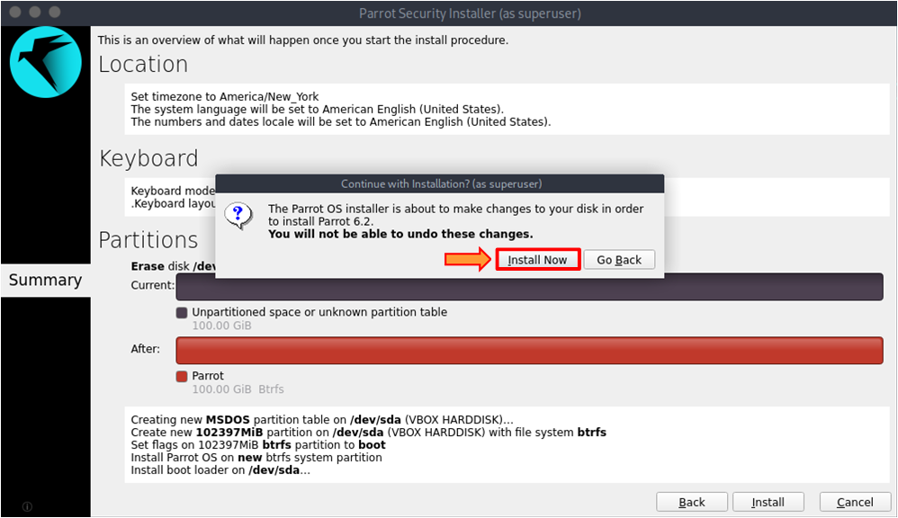
23. The installation process starts it will take time to complete a process.
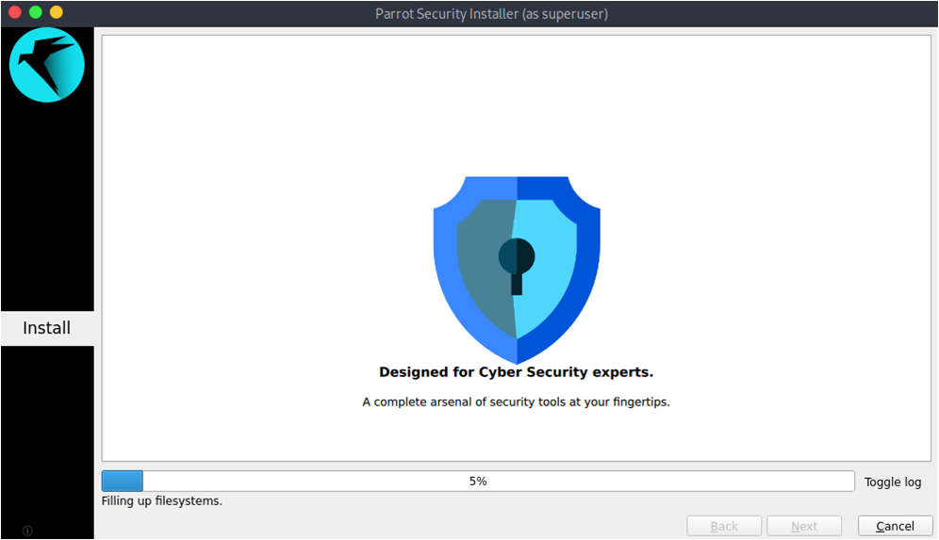
24. If we restart the ParrotOS, then it again goes to the installation process. To avoid this, we need to remove the ISO file that is attached to the VM. When the installation process is completed, an All done window appears. Uncheck the Restart now check box. Then click on the Done button.
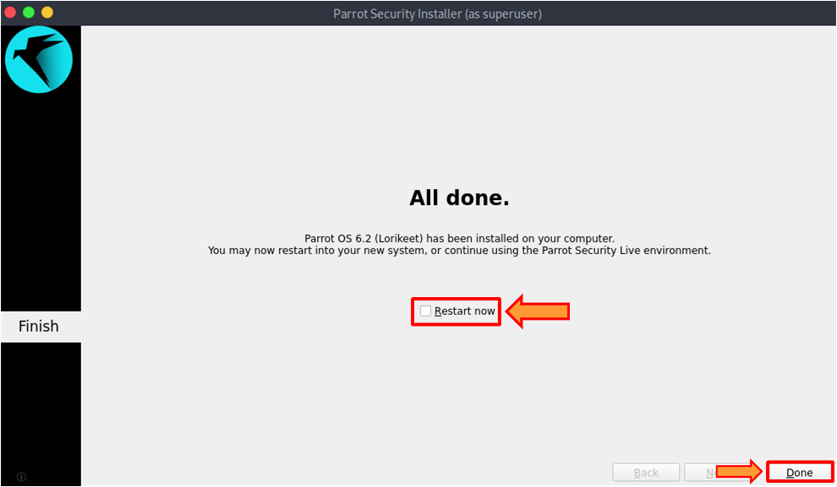
25. Click on the Menu at the bottom. Then click on the Power button.
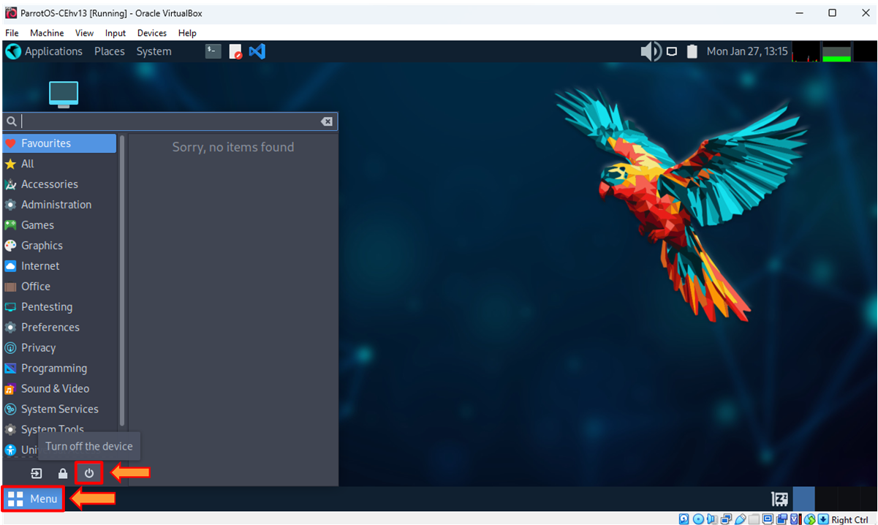
26. Shut down this system now? window appears. Click on the Shut Down button.
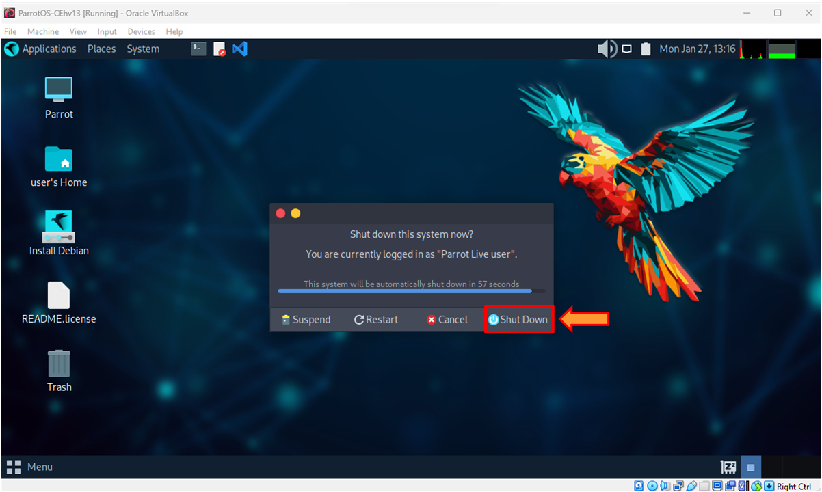
27. Select the ParrotOS-CEhv13. Then click on the Settings.
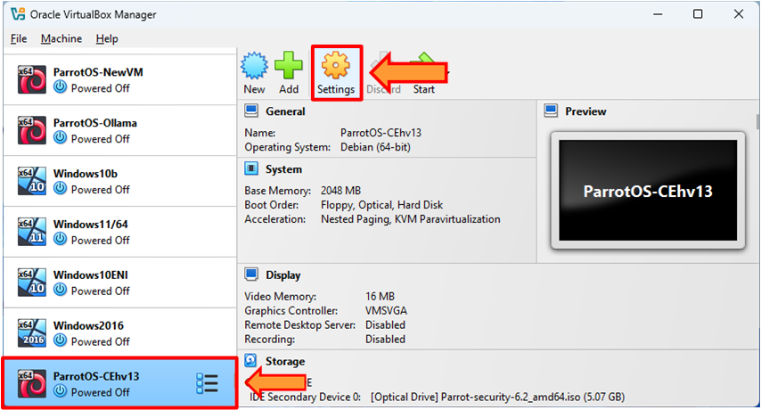
28. Click on the Storage. Right-click on the Parrot-security-6.2_amd65.iso. Then click on the Remove Attachment.
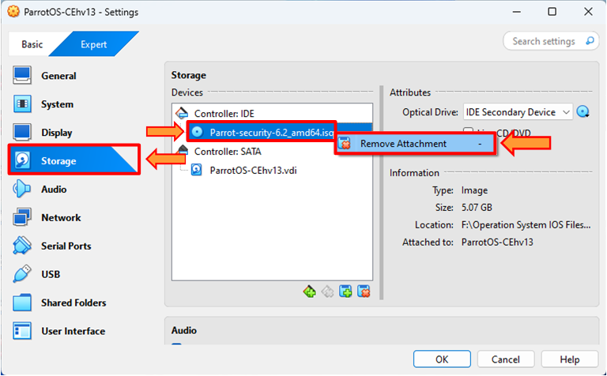
29. A pop-up appears Are you sure you want to delete the optical drive? Click on the Remove button.
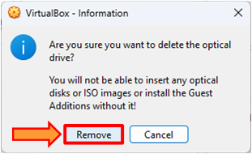
30. Click on the OK button to save the changes.
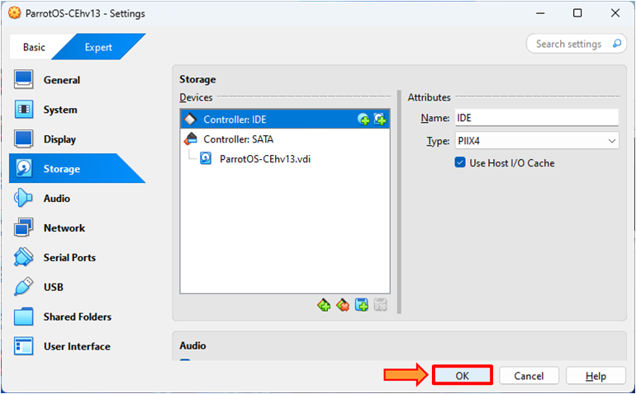
31. Select the ParrotOS-CEhv13 VM and click on Start.
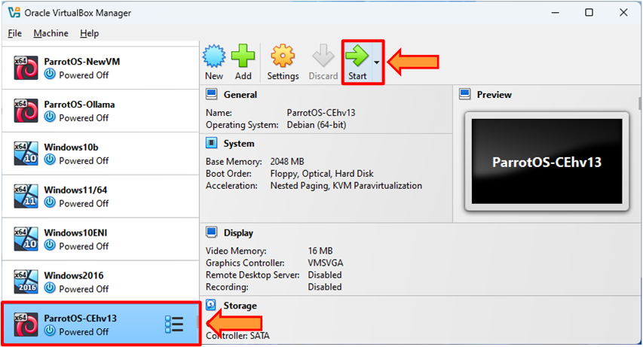
32. A login screen appears. Enter your password, which you set when you were doing the installation, and then click the Log in button.
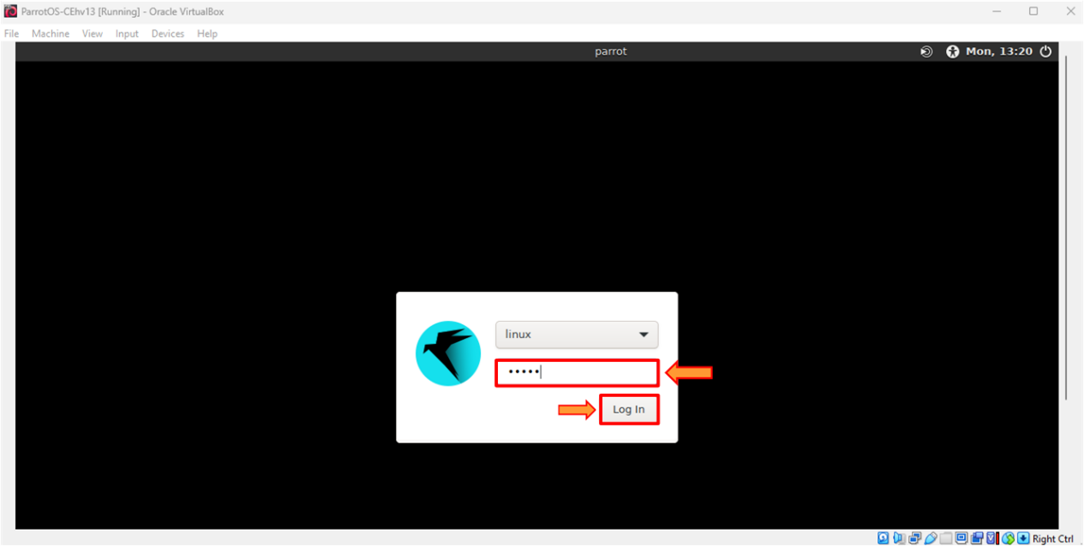
33. We have successfully created the Parrot Security VM in the Oracle VirtualBox.
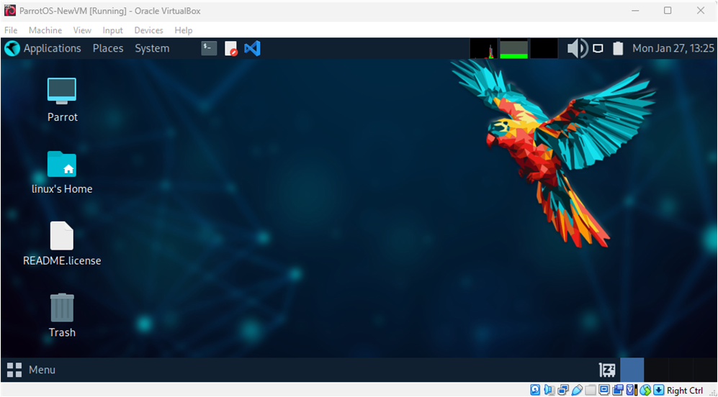

Lab 1-03 Windows 10 VirtualBox Installation
1. Open any browser and go to the following URL. Click on the Download button to download the Windows 10 official ISO file.
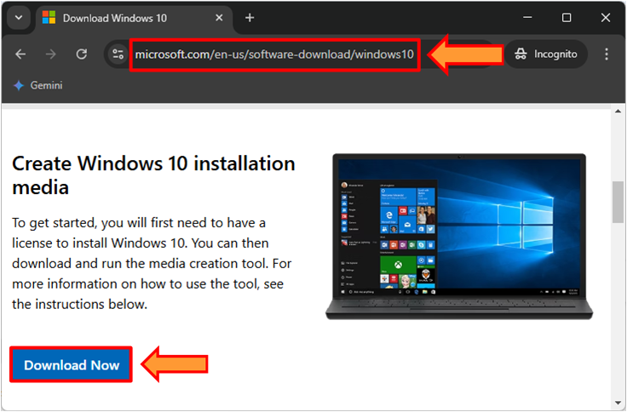
2. Open the Oracle VirtualBox, then click on the New.
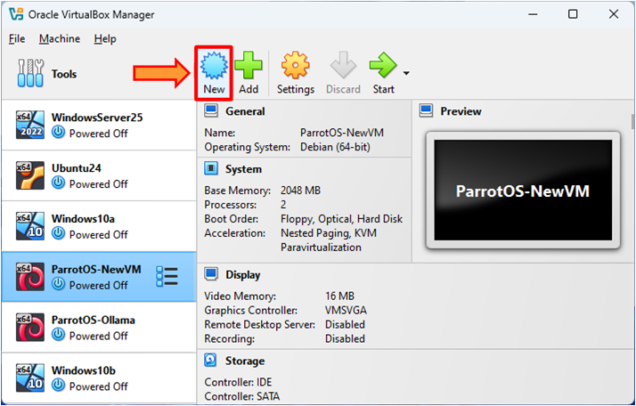
3. In the Name, enter the name of VM Windows10-CHHv13. In the Folder, select your desired destination to store it. In the Type, select the Microsoft Windows. In the Version, select the Windows 10 (64-bit). After that, click on the Hardware arrow icon.
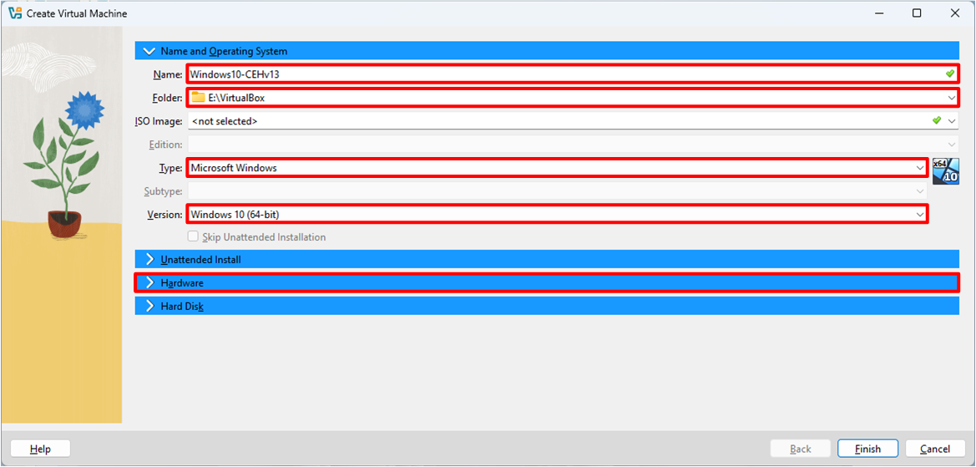
4. In the Base Memory, enter the memory according to your system capacity. For this lab, we are entering 3048 MB, which is around 3 GB. Then click on the Hard Disk arrow icon.
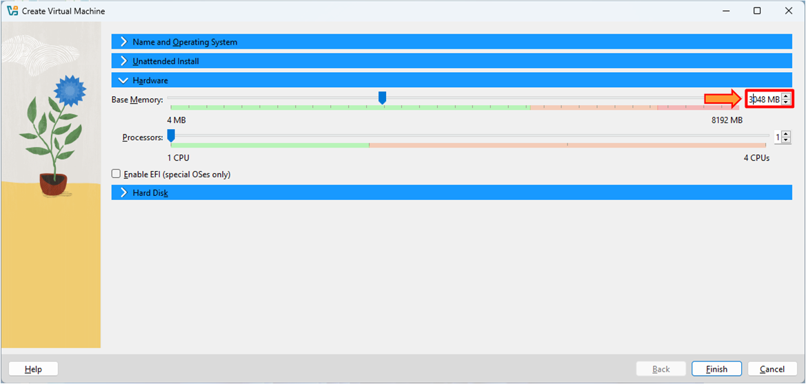
5. In the Hard Disk File Location and Size, enter the hard disk size according to your system capacity. For this lab, we are entering 100 GB. Then click on the Finish button.
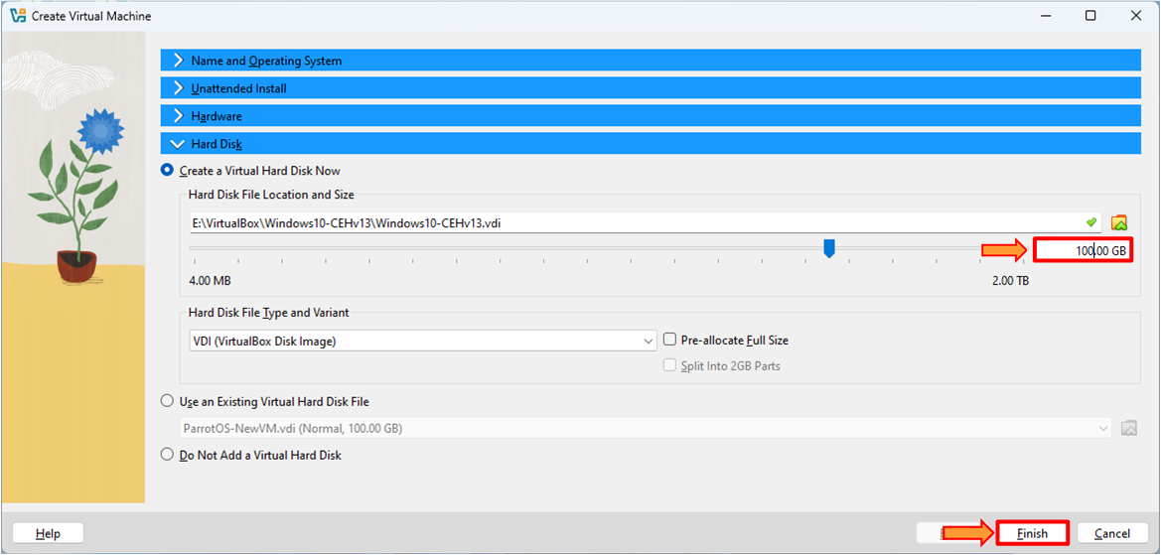
6. The VM is created, but this IOS file is not attached to it. To attach the ISO file, click on Settings.
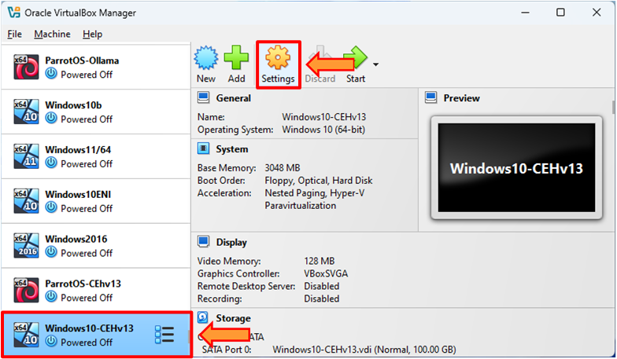
7. Click on the Storage. Click on the Empty. Then click on the Choose a Disk File….
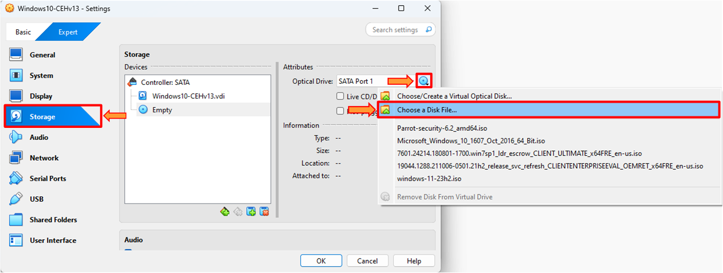
8. The Please choose a virtual optical disk file window appears. Select the Windows 10 ISO file. Click on the Open button.
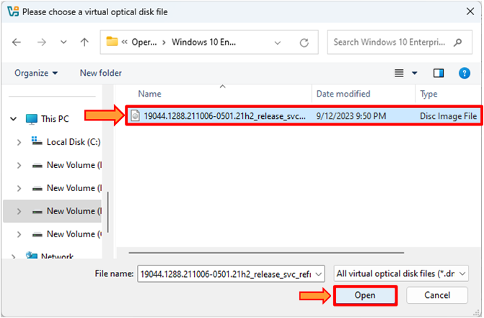
9. Click on the OK button.
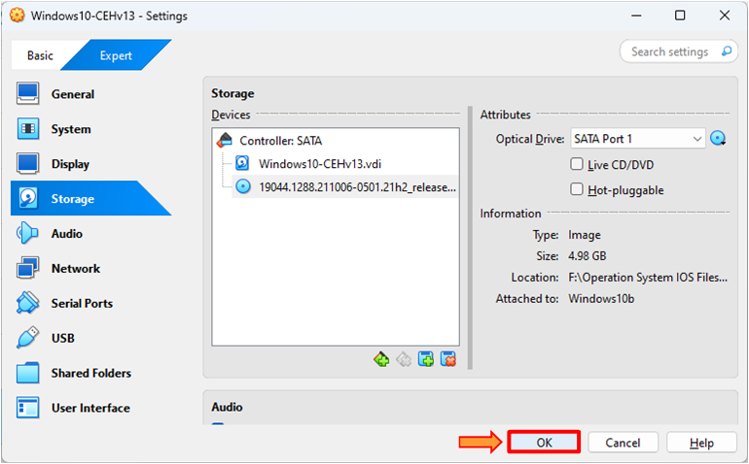
10. Select the Windows10-CHHv13 VM and click on Start to proceed with the installation process.
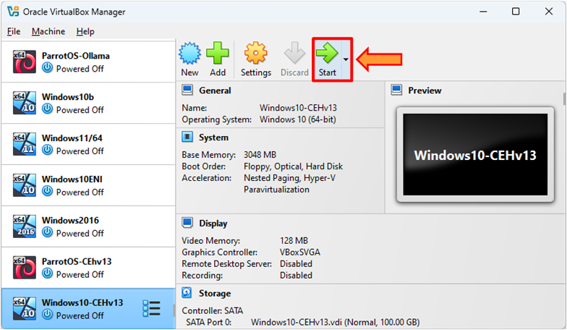
11. Leave everything as default. Click on the Next button.
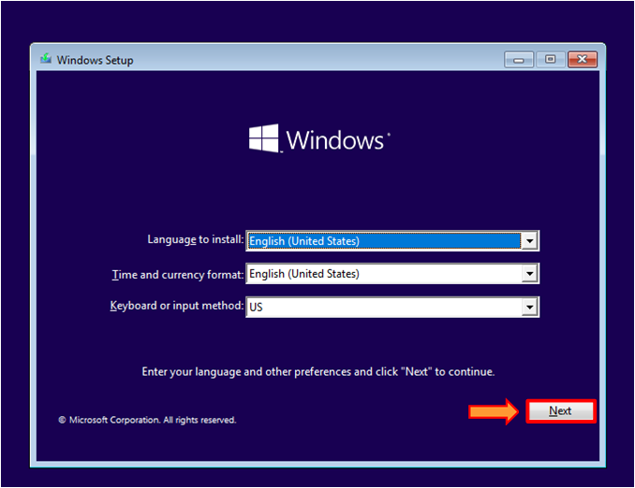
12. Click on the Install.
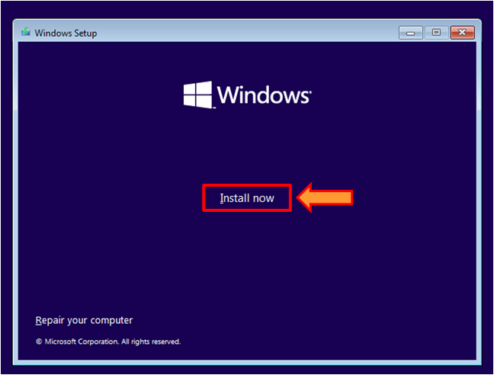
13. The Windows Setup window appears. Click on the I accept the license terms checkbox. Then click on the Next button.
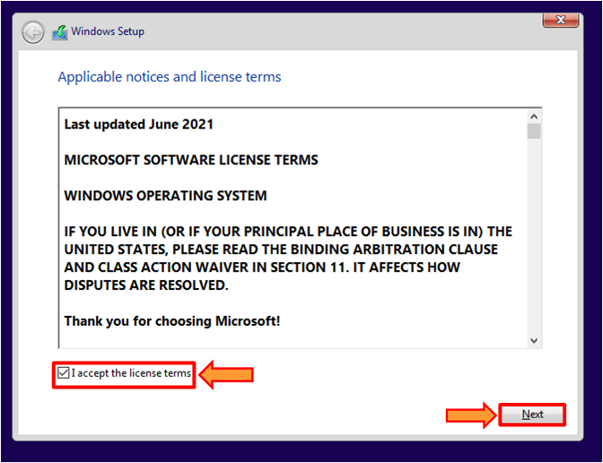
14. Click on the Custom: Install Windows only (advanced).
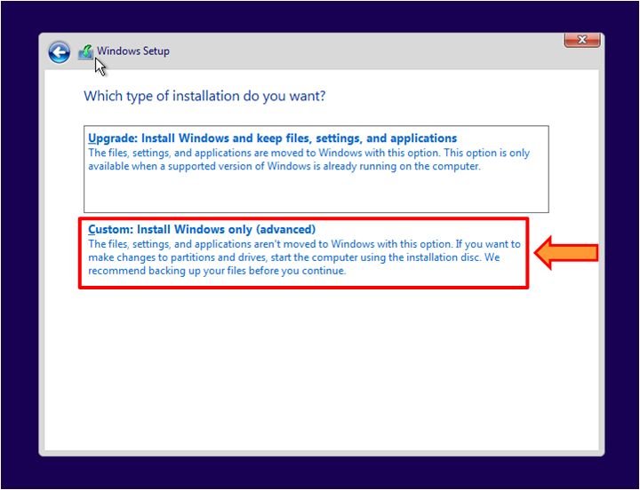
15. Click on the New to create a hard drive partition.
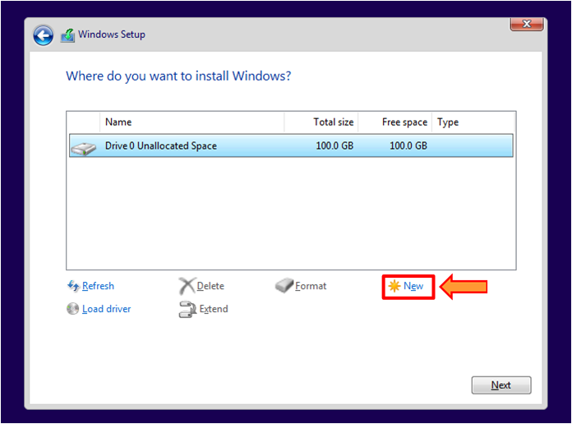
16. Click on the Apply. You can adjust partition size according to your need or create more than one partition. We are creating here only one partition of 100 GB.
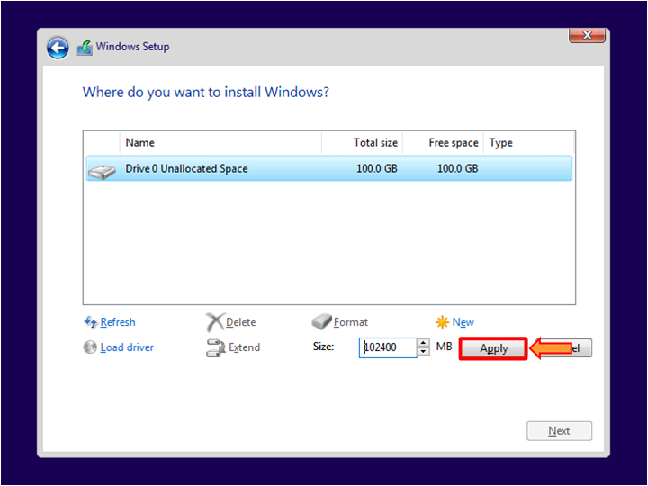
17. The Windows Setup pop-up appears. Click on the OK button.
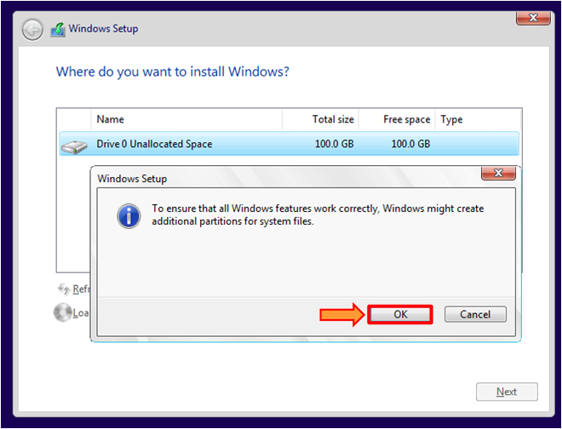
18. We create only one partition, but it creates a second one by itself. Windows creates a 50MB partition, often called a System Reserved partition, primarily to store essential boot-related files for the operating system. Click on the Next button.
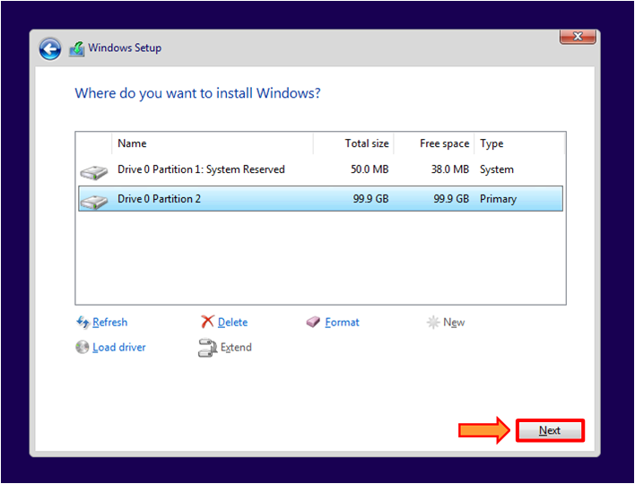
19. The Windows installation process starts it takes some time to complete.
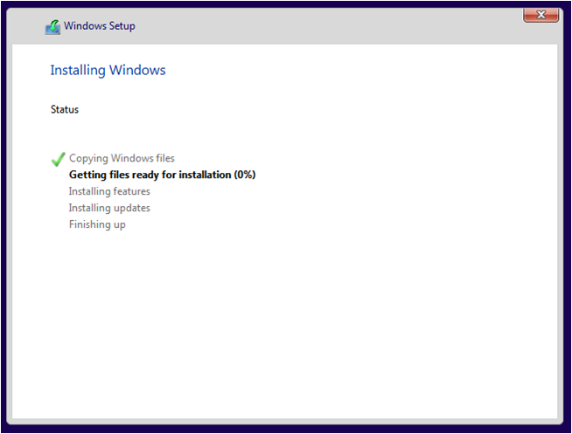
20. After the installation process is completed. Now, you need to set a few settings to complete the process. Select your desired region here, we select the United States. Then Click on the Yes.
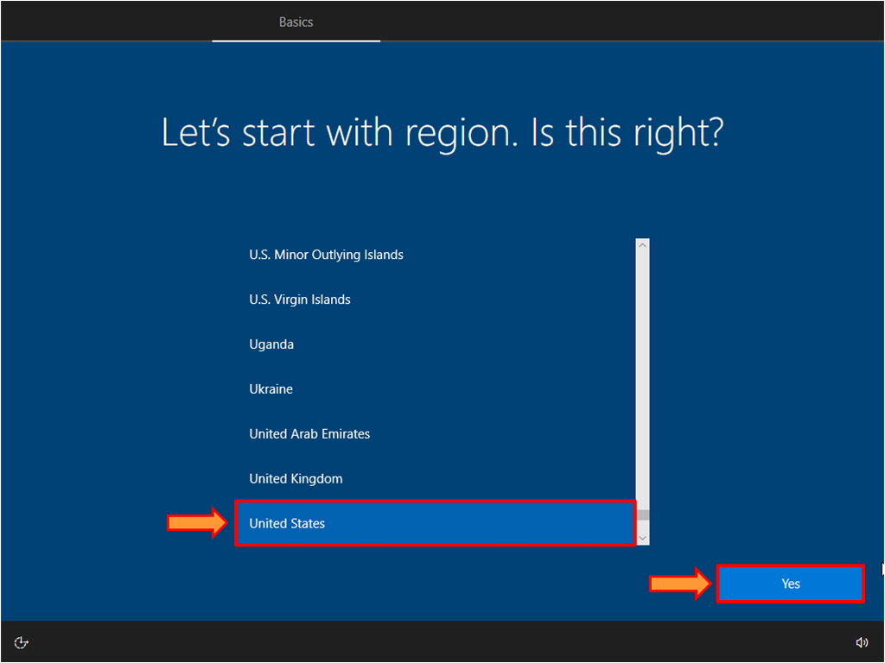
21. Select the US keyboard layout or select your desired keyboard layout. Click on the Yes.
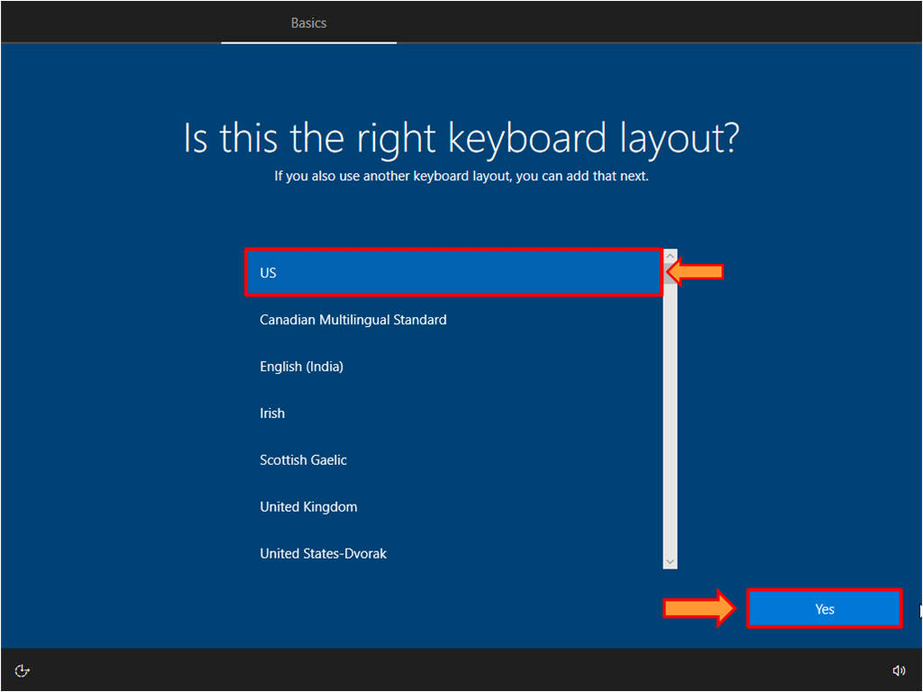
22. If you want to add a second keyboard layout then click on Add layout. Otherwise, click on Skip.
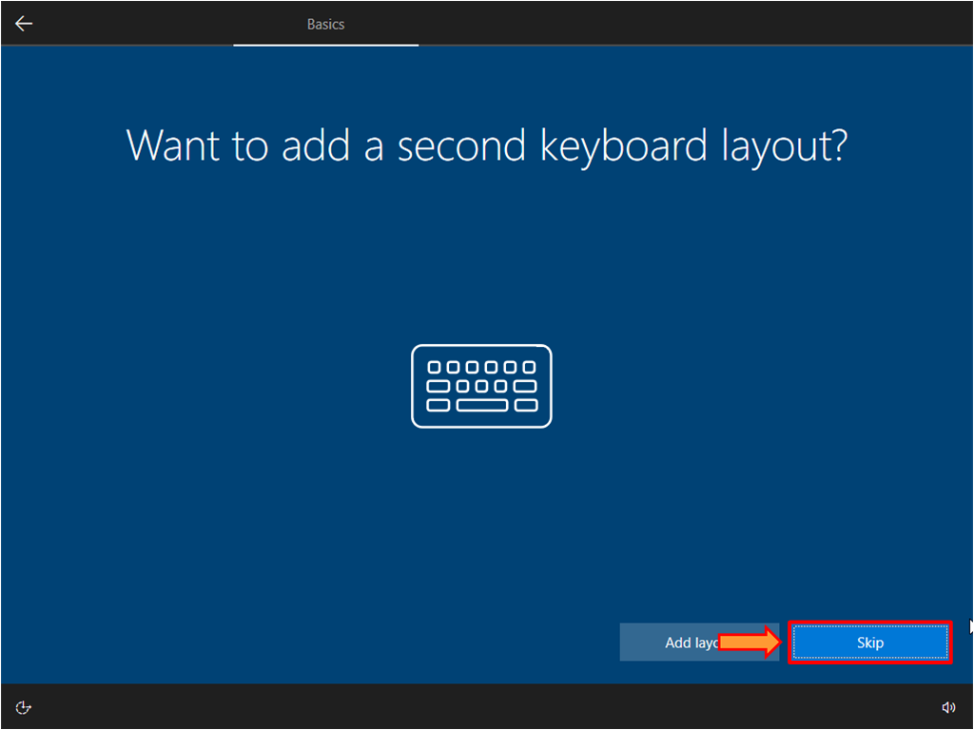
23. Click on the Domain join instead.
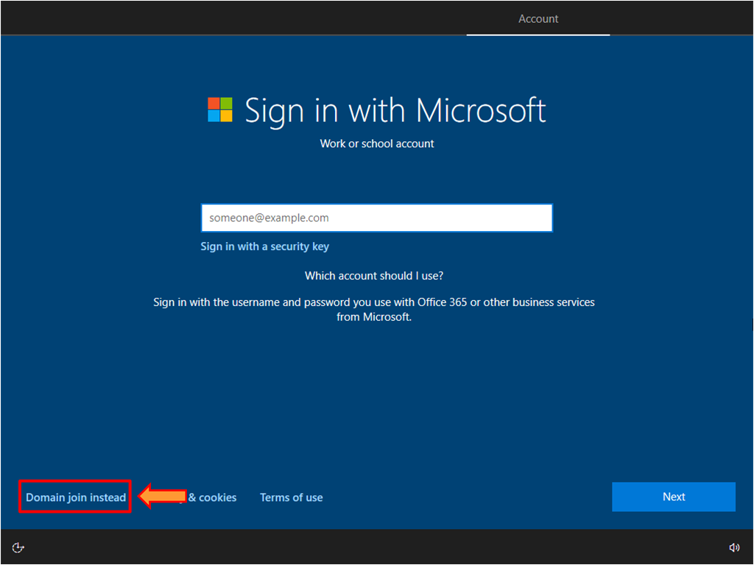
24. Add your username and click on the Next.
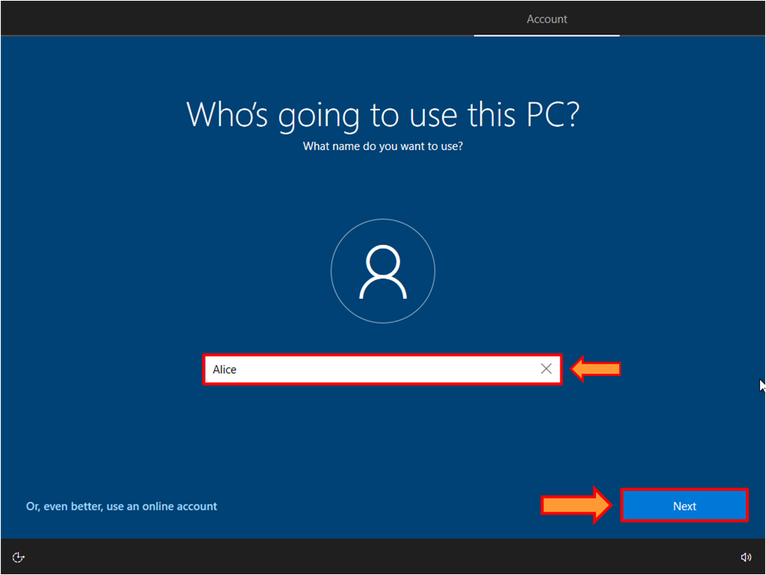
25. Set your desired password and click on the Next.
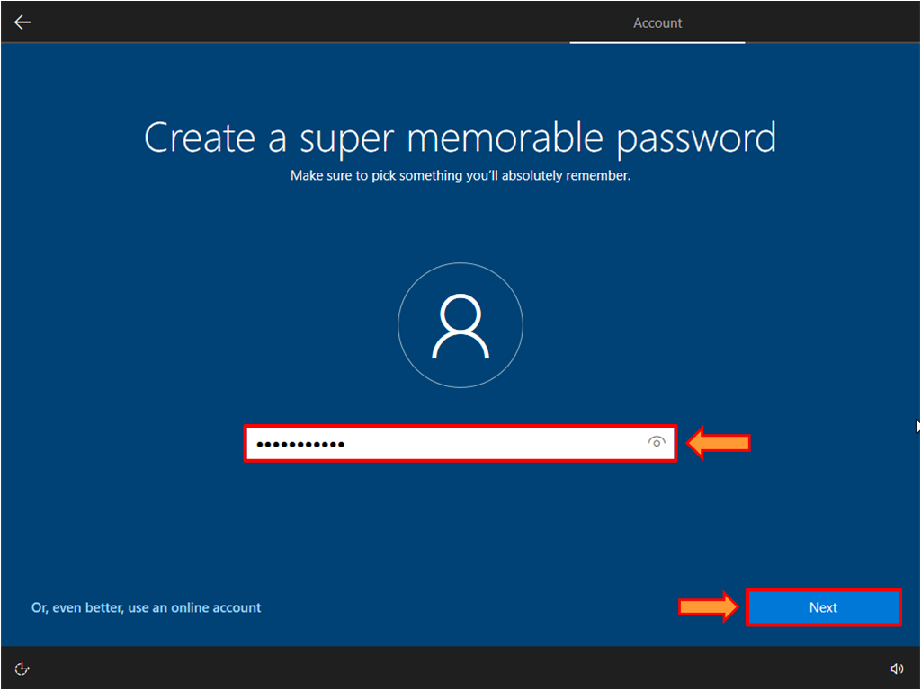
26. Now confirm your password and click on the Next.
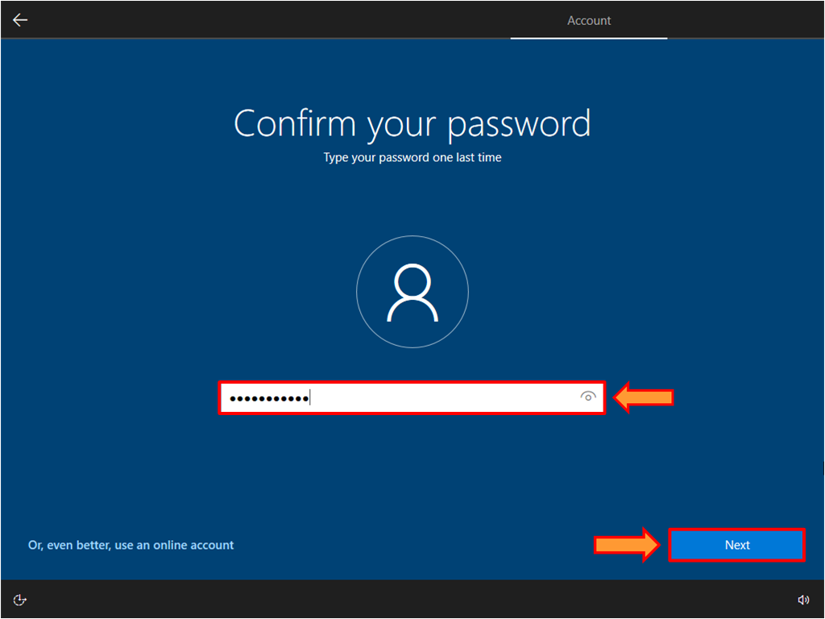
27. Create three security questions in case you forget your password, and make sure that these questions are related to the password you set earlier in Step#25 so that you can easily remember your password. You can select any three questions you answer easily and remember them. After question selection and give their answers click on the Next.
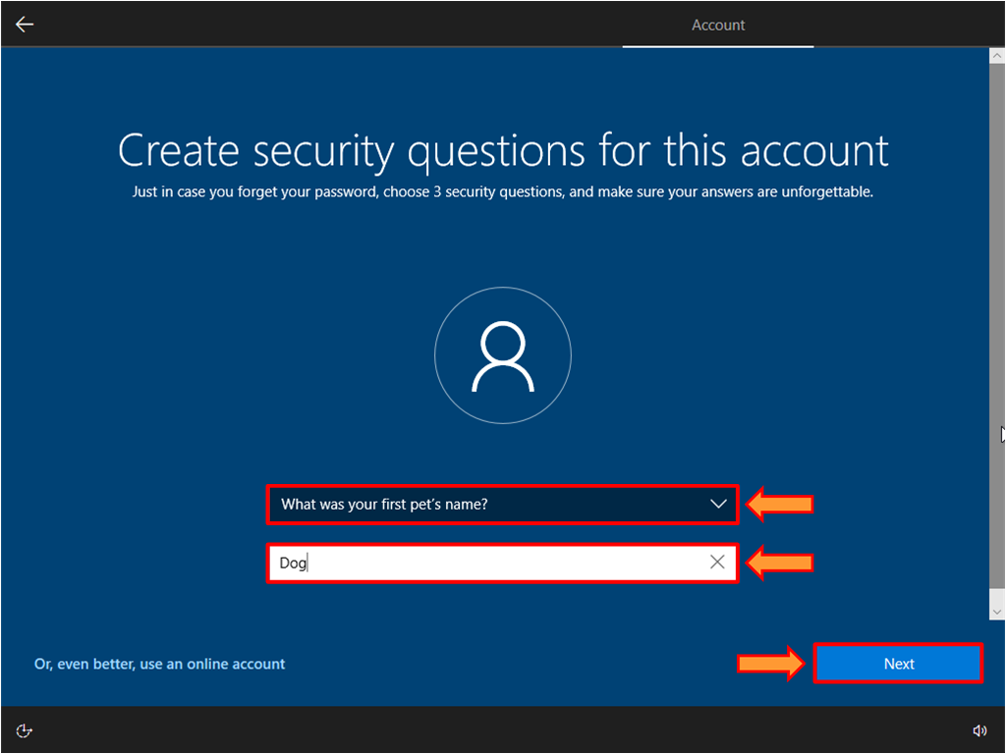
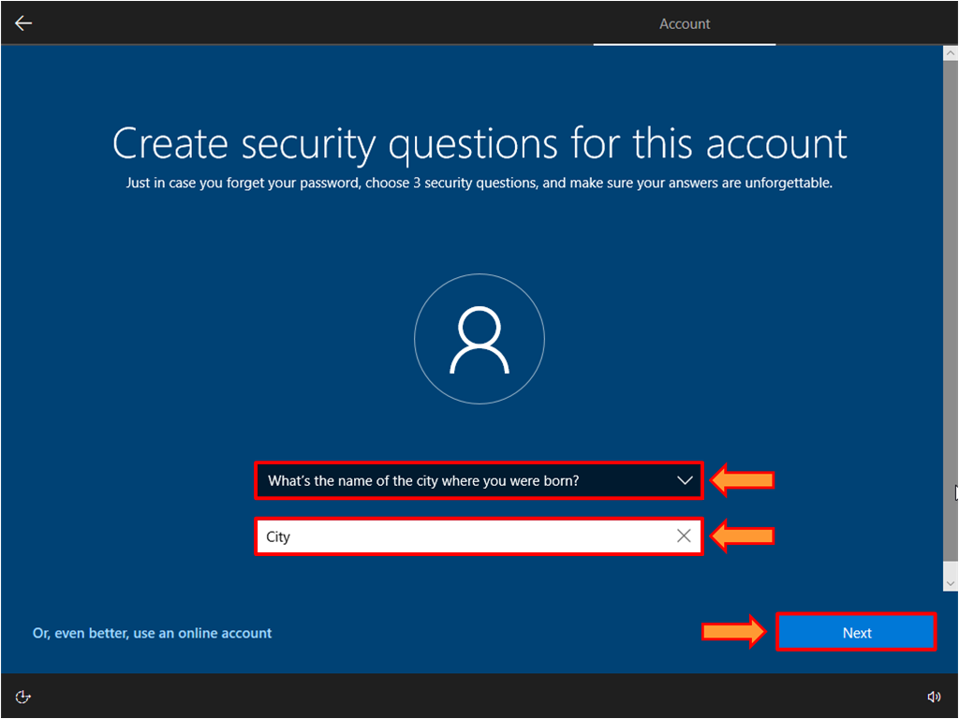
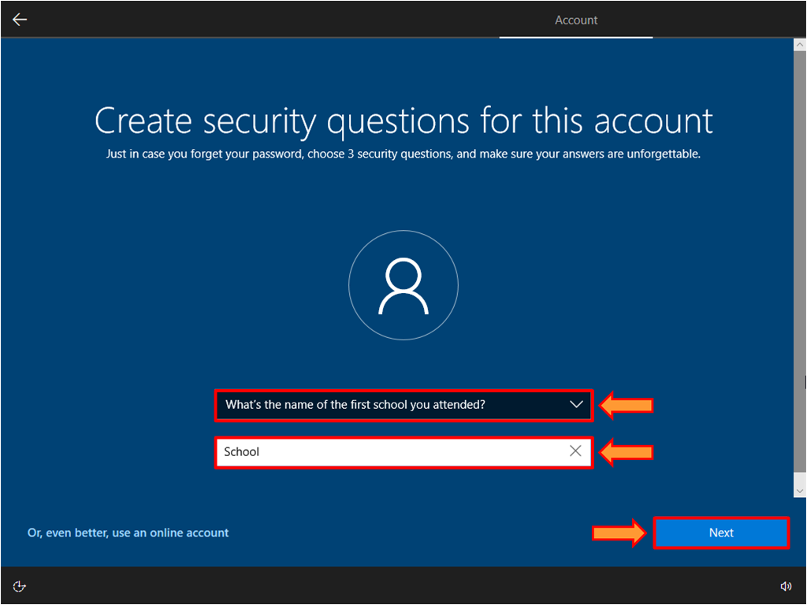
30. Click on the Accept.
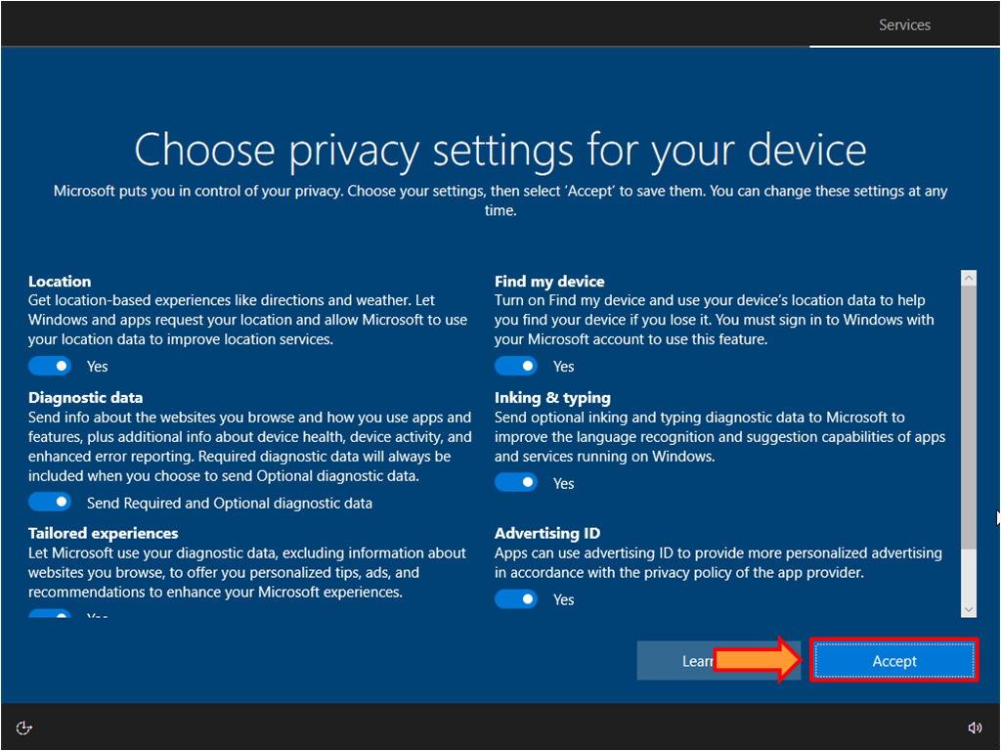
31. If you want to enable Cortana, click Accept. Otherwise, click on the Not now.
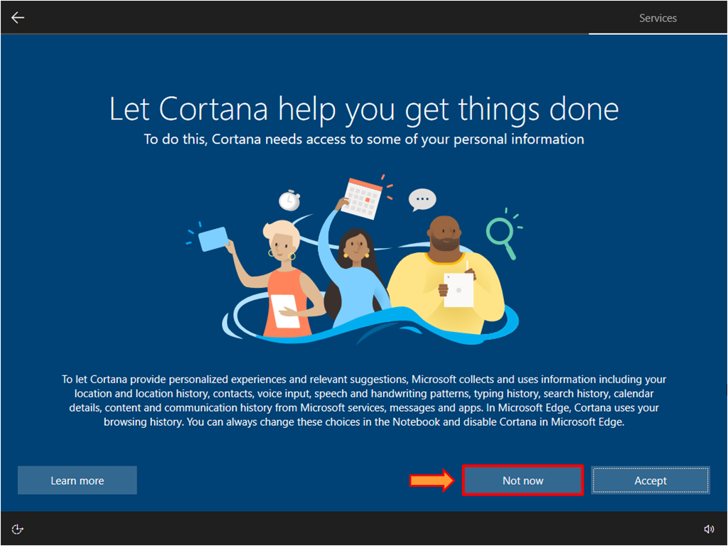
32. It will take a few minutes to complete the final setup. Do not turn off your computer or restart.
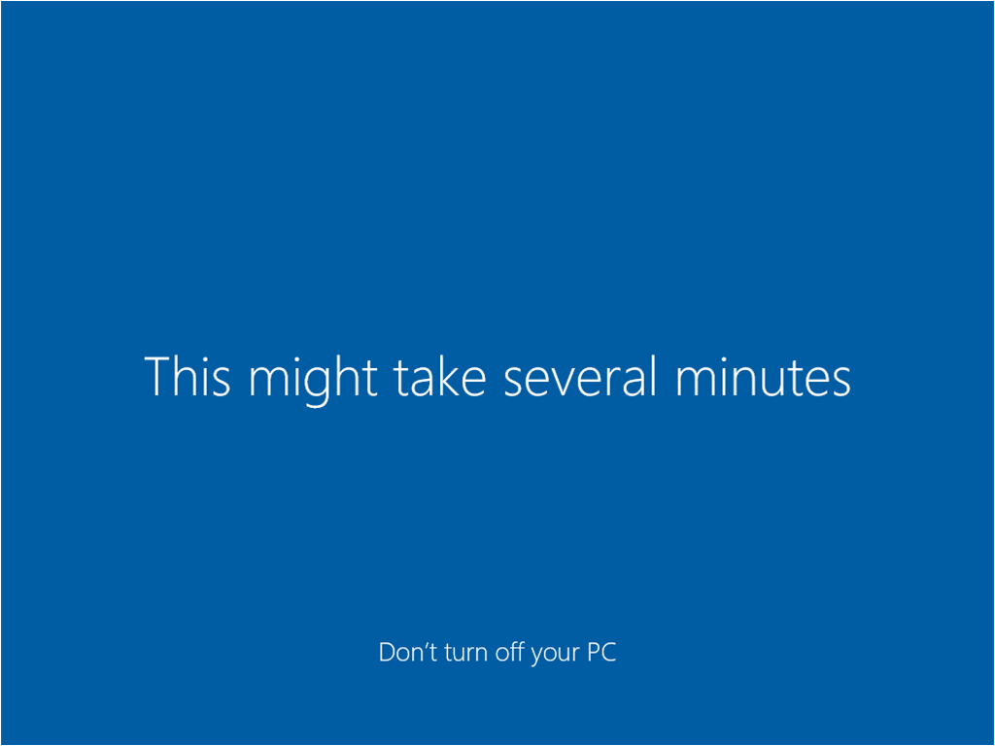
33. We have successfully installed Windows 10 in the VirtualBox.
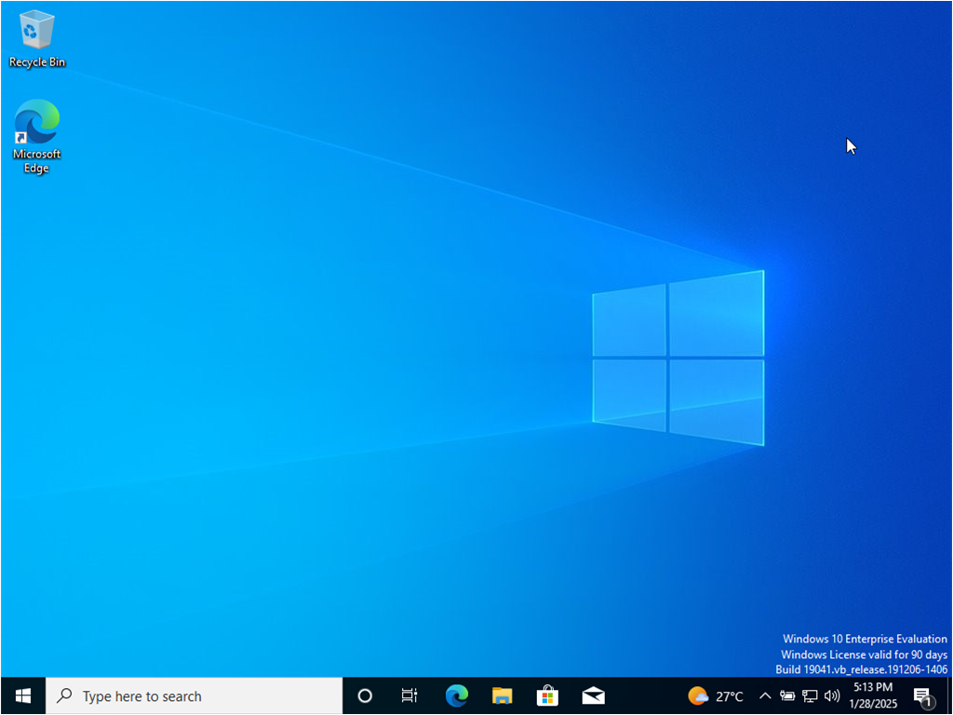

Lab 1-04: Integrate ShellGPT in the Parrot Security Machine
1. Visit the OpenAI platform using following URL: https://platform.openai.com and sign up or log in to your existing account.
2. Once logged in, click the profile icon at the top-right, click Your profile option, and navigate to the Billing section.
3. Under the Billing section, go to Payment methods and click Add payment method to add a payment method.
4. Go to Overview and click Add to credit balance.
5. Enter the minimum amount, i.e., $5 for Amount to add, and click continue. For more information about API pricing details, go to the following URL: https://openai.com/api/pricing/.
6. Click Confirm payment and complete the transaction to add the credit balance.
7. Now, switch to the ParrotOS machine and open any web browser. Go to https://platform.openai.com/api-keys.
8. An OpenAI Platform webpage appears. Click on Login and log in to the OpenAI account that you created at the start of this lab.
9. You will be redirected to the Project API Keys window. Click on + Create new secret key button to create a new key.
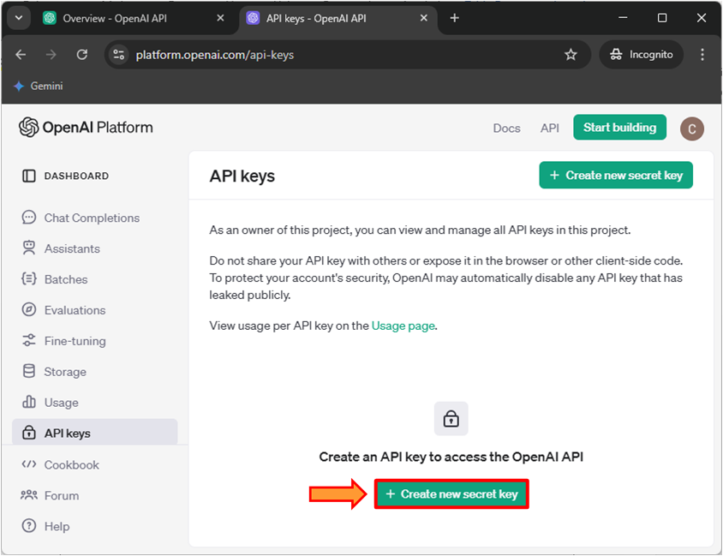
10. A Create new secret key window appears. Provide a name for the secret key here, CEH, and leave all the settings as default, as shown in the screenshot, and click on the Create secret key button.
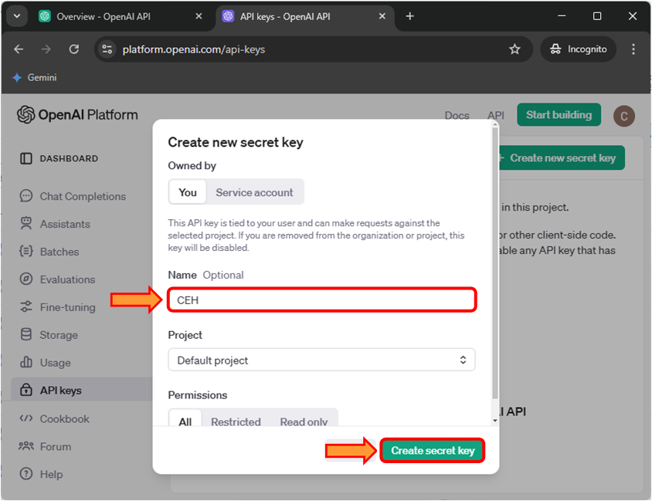
11. Save your key pop-up appears. Click the Copy button to copy the key. Save this key in a notepad. We will be using this key in each module for setting up ShellGPT.
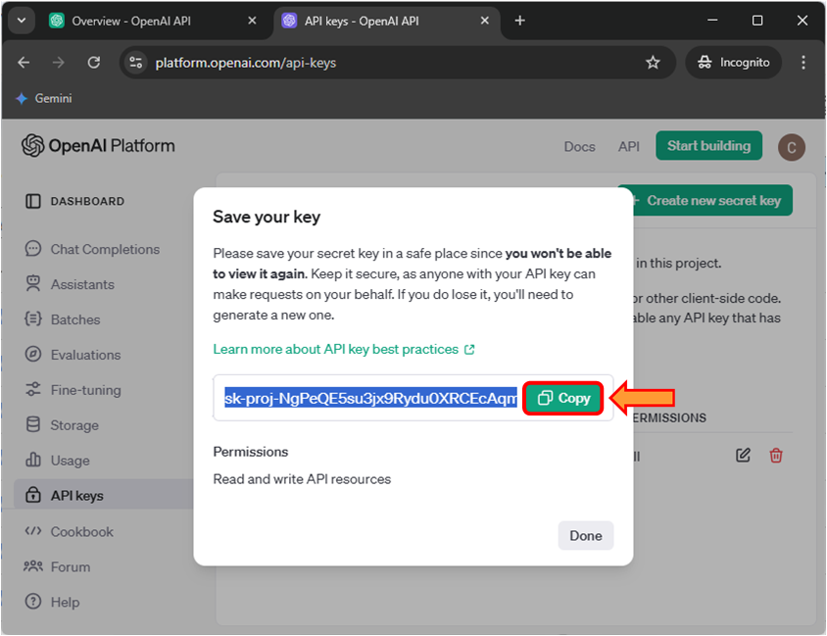
14. Now, open a Terminal and execute the sudo su command to run programs with superuser privileges. When prompted, enter your password toor.
15. Execute the following command pip install shell-gpt –break-system-packages to install the ShellGPT tool.
16. Execute the sgpt command to launch the ShellGPT tool.
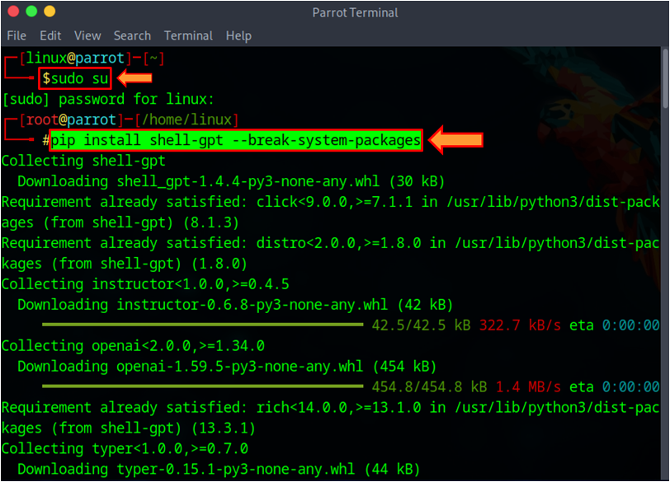
17. You will be prompted to enter your OpenAI API key, paste the copied API key in the terminal window and press Enter. The secret key you have entered will not be visible.
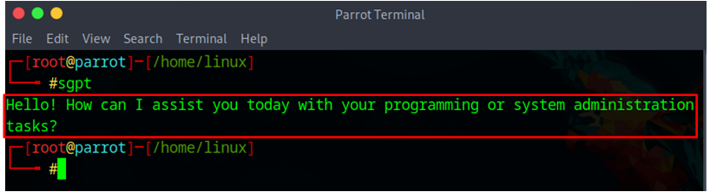
18. If the API key integration is successful, you should receive a message, as shown in the screenshot. We have successfully integrated ShellGPT API. We will use ShellGPT in the upcoming lab tasks.

